2403a52424 – AI LAB EXAM
SET 5
- Design a schema for a Hospital patient management system.
b) Write SQL queries for retrieving patient history and prescribed medicines
Prompt:
We create and write queries for table and do insertion for values and make a rough schema for the Hospital patient management system.

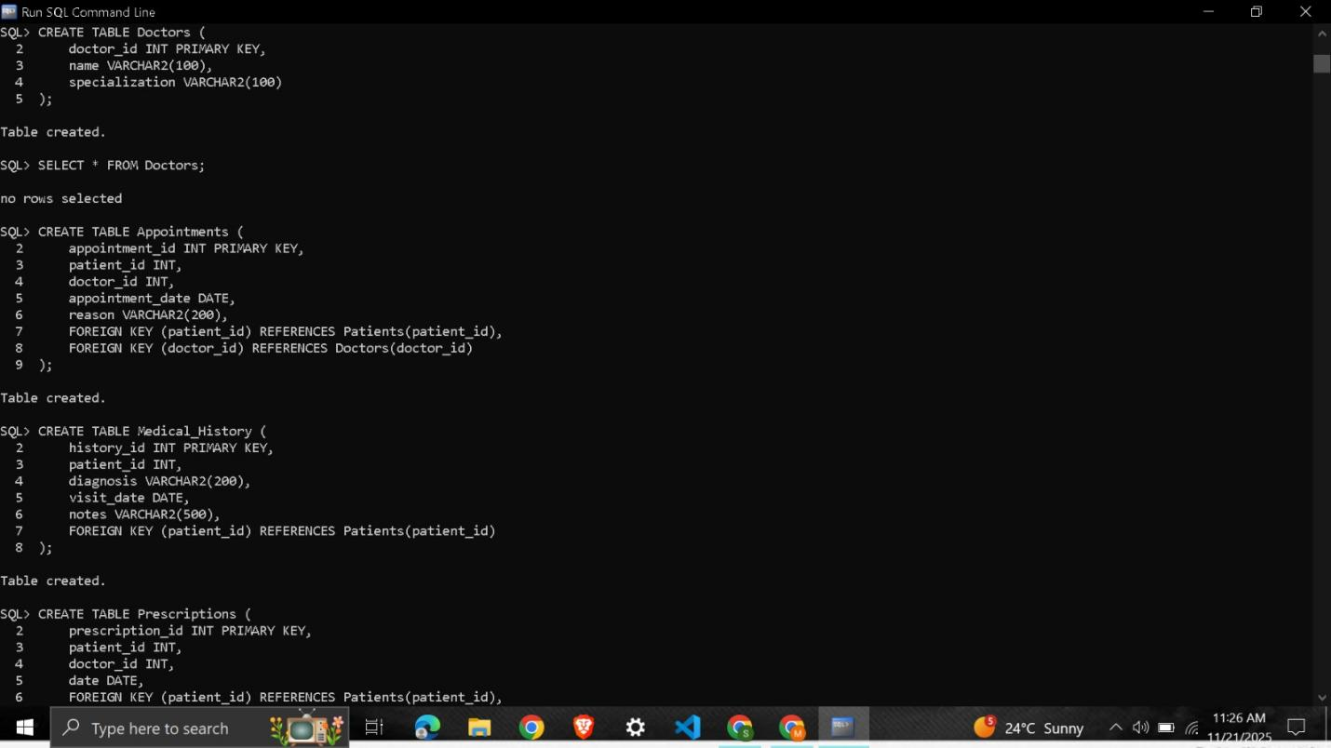
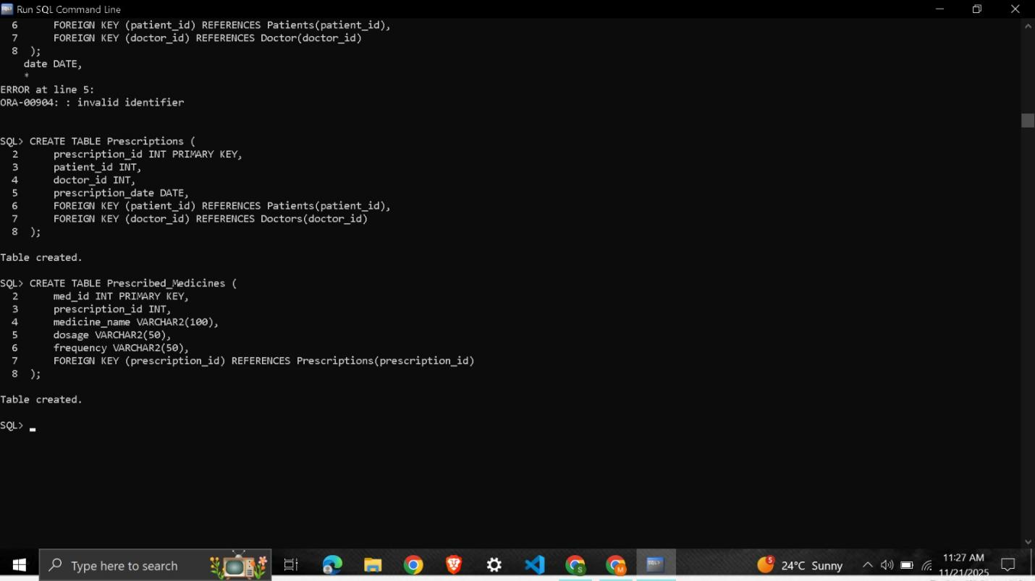
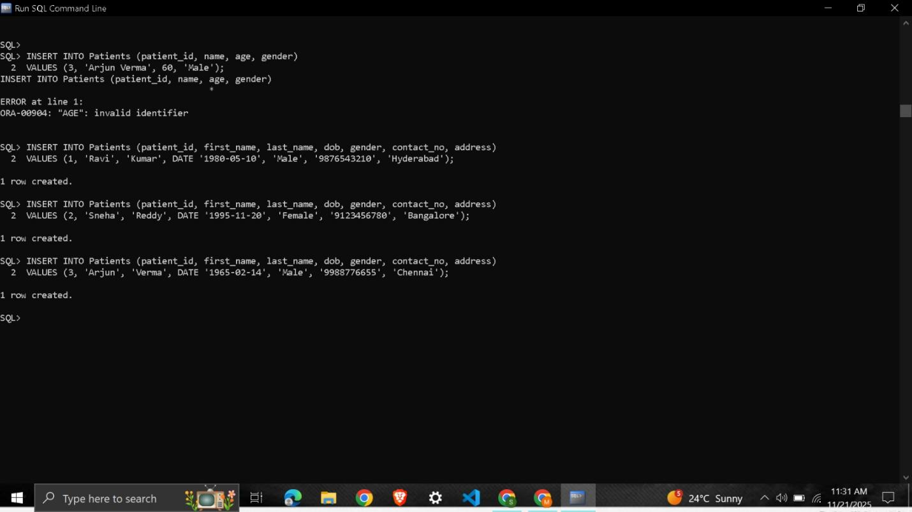
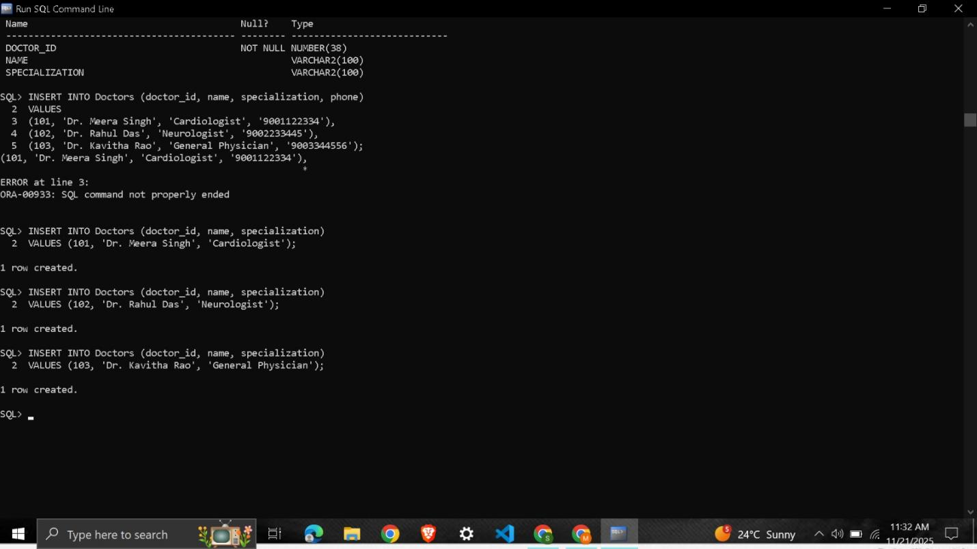
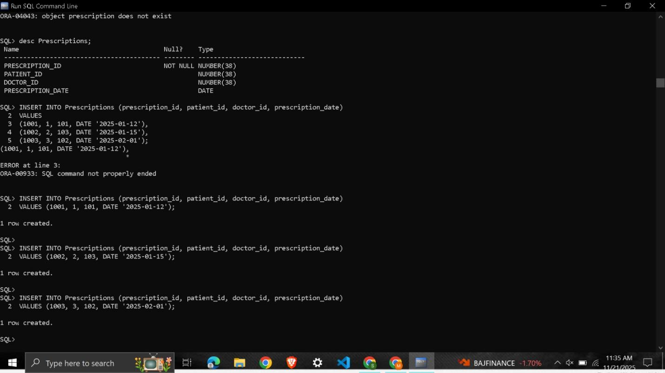
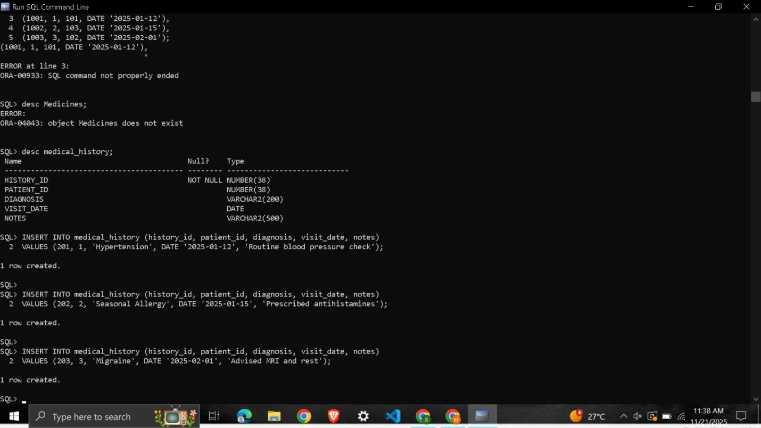
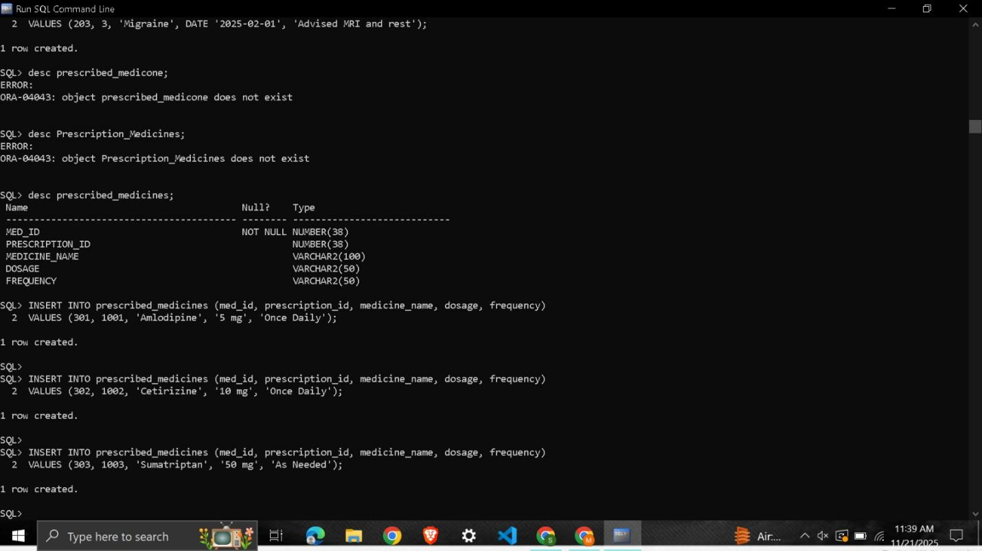
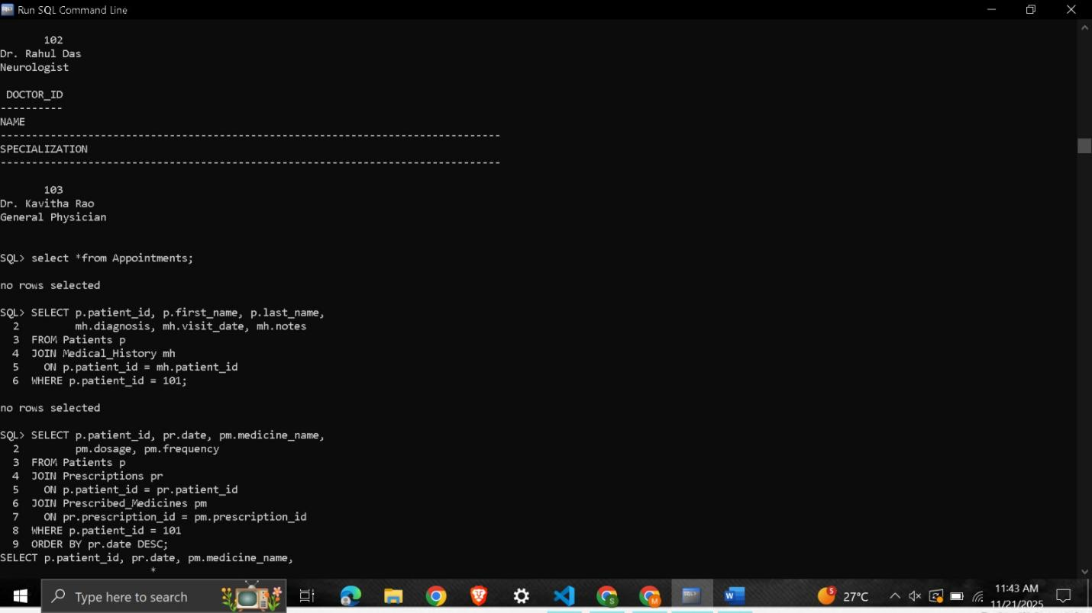
ER diagram for the schema:
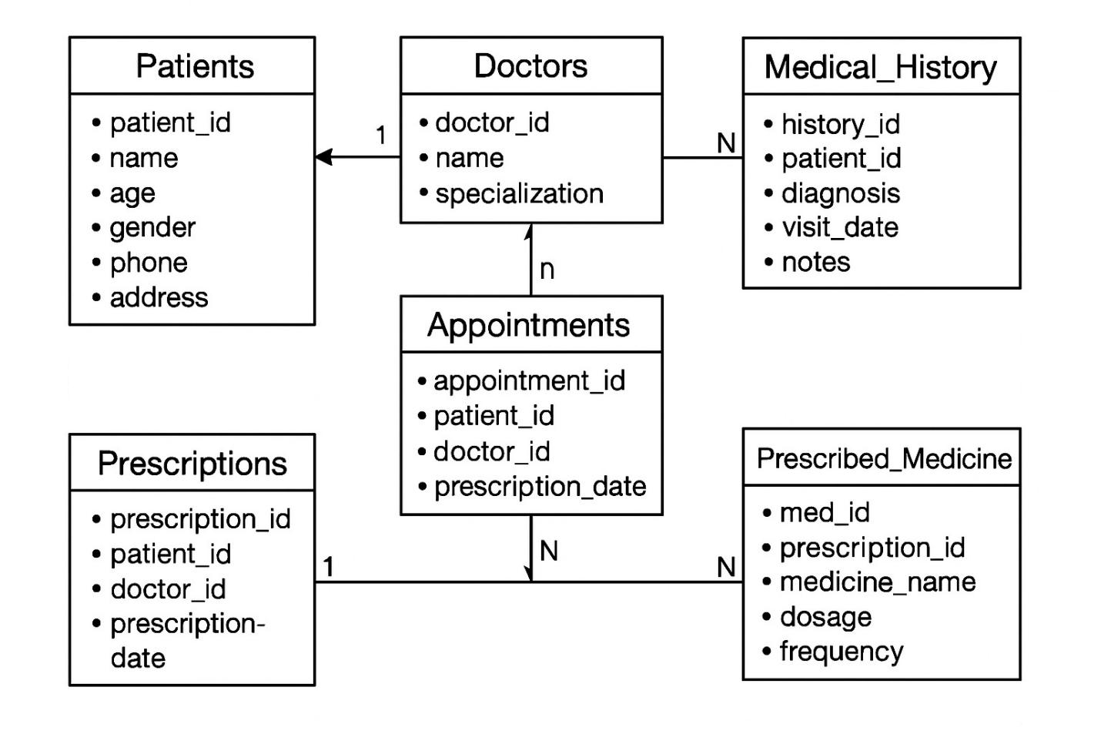
Q2. (AI Data Processing)
a) Write AI-assisted code to handle missing medical sensor readings.
b) Normalize numerical fields like heart rate & blood pressure
Prompt: Write AI-assisted Python code that handles missing medical sensor data (e.g., heart rate and blood pressure) by imputing missing values, and normalize the numerical fields to prepare the data for machine learning."
Code A :
import pandas as pd
from sklearn.impute import KNNImputer

# Sample medical sensor data
df = pd.DataFrame({
'heart_rate': [72, 85, None, 90, None],
'bp_systolic': [120, None, 130, 140, None],
'bp_diastolic': [80, 85, None, None, 82]
})

# AI-assisted missing value imputation using KNN
imputer = KNNImputer(n_neighbors=2)
df_imputed = pd.DataFrame(imputer.fit_transform(df), columns=df.columns)

print("Before Imputation:\n", df)
print("\nAfter KNN Imputation:\n", df_imputed)
output:
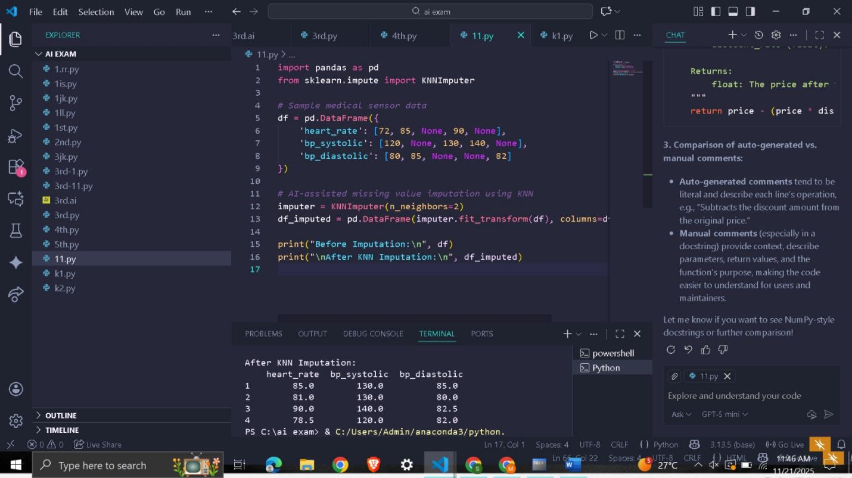
Code B:
from sklearn.preprocessing import MinMaxScaler, StandardScaler
import pandas as pd

# ---- SAMPLE DATA / DEFINE df_imputed ----
data = {
'A': [1, 2, 3, 4],
'B': [10, 20, 30, 40],
'C': [5, 6, 7, 8]
}
df_imputed = pd.DataFrame(data)

# Min-Max Normalization (0 - 1)
minmax = MinMaxScaler()
df_minmax = pd.DataFrame(minmax.fit_transform(df_imputed), columns=df_imputed.columns)

# Z-score Normalization
scaler = StandardScaler()
df_standard = pd.DataFrame(scaler.fit_transform(df_imputed), columns=df_imputed.columns)

print("\nMin-Max Normalized Data:\n", df_minmax)
print("\nStandardized Data:\n", df_standard)
output:
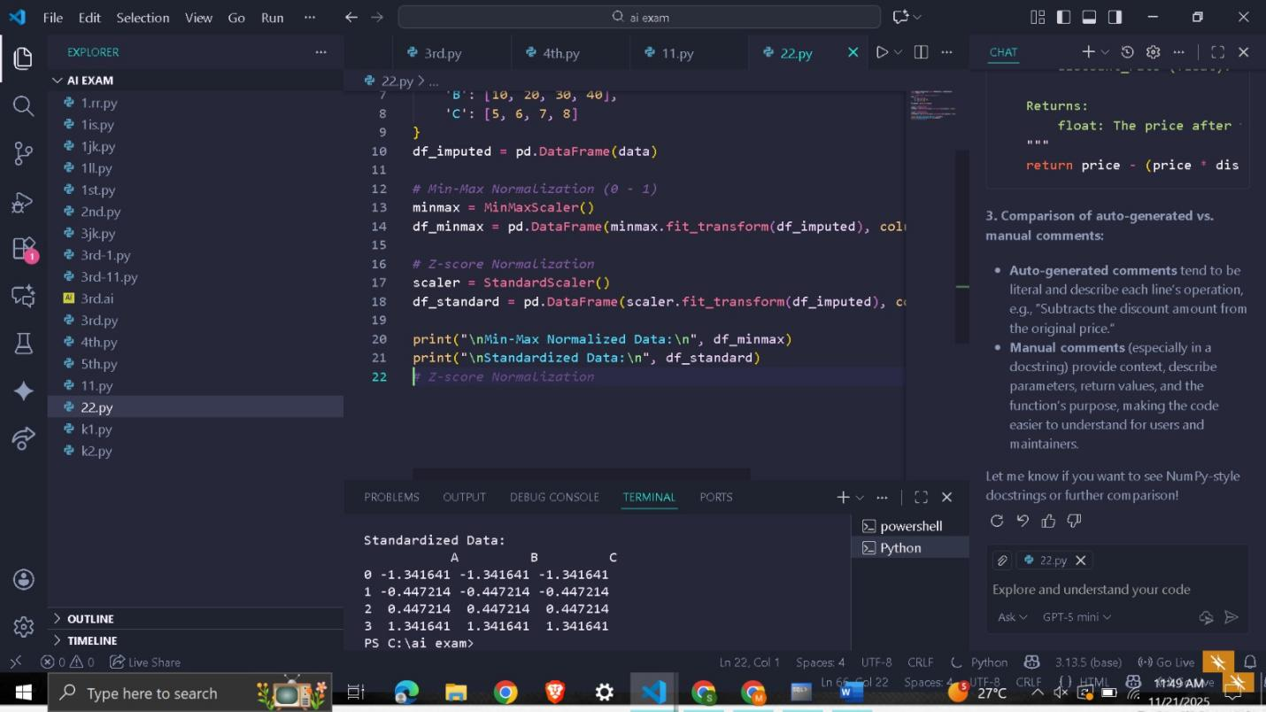
Explanation
A) Handling Missing Medical Sensor Readings
Medical devices may fail, give delayed signals, or temporarily disconnect, which results in missing values.
To fix this, the code uses:
SimpleImputer(strategy="mean")
This replaces missing values with the average of the existing data.
This ensures:
No patient record is lost
Machine learning algorithms can process the dataset
Data remains realistic and consistent

B) Normalizing Heart Rate and Blood Pressure
Different sensor values have different measurement scales (e.g., heart rate ~90 bpm vs. systolic BP ~140).
To make them comparable for AI models, we normalize them using:
MinMaxScaler()
This converts values into a 0–1 range, which:
Improves machine learning accuracy
Avoids scale-dominated features
Makes patterns more meaningful in analytics and visualization

